UNIVERSITY INSTITUTE OF COMPUTING

PROJECT REPORT
ON
Air Quality Data Analysis of Chandigarh
Python Mini Project / Case Study
SUBJECT CODE: 25CAH-221

SUBMITED BY:

Name : Varun thakur UID : 25BCD10122

Branch : BCA Data Science Group: ‘B’ Section:25BCD (2)

Semester : 3^{rd’}

SUBMITED TO:

Name : Mrs.preeti verma D.O.SUBMITION : 8/10/2026

Desigination: Assistant professor
Sign:____________________

Project Report: Air Quality Data Analysis of Chandigarh

1. Title
Air Quality Data Analysis of Chandigarh using Python
This case study demonstrates a beginner-friendly data-analysis workflow for exploring air-pollution measurements associated with Chandigarh. The project uses Python, pandas, NumPy and Matplotlib to organize a small tabular dataset, calculate descriptive summaries, compare pollutant values, and create graphs. The values used in the demonstration are simulated for academic practice; they are not measured observations from Chandigarh and must not be presented as official monitoring data.

2. Aim / Introduction of the Project
The aim of this mini-project is to demonstrate how a structured dataset can be used to study patterns in common air pollutants and communicate those patterns through visualizations. Air quality is influenced by multiple sources, including road traffic, construction dust, industrial activity, seasonal conditions and regional weather. A data-analysis project can help students practise data cleaning, descriptive statistics, comparison and interpretation. However, reliable environmental conclusions require validated readings from recognized monitoring stations, correct units, sampling timestamps and suitable quality-control procedures.
For this report, a 30-day illustrative dataset is generated with columns for PM2.5, PM10, NO2, SO2 and CO. A simple weighted project indicator is calculated from PM2.5 and PM10 to illustrate derived metrics. This indicator is only a classroom calculation; it is not the official Central Pollution Control Board (CPCB) Air Quality Index (AQI), does not use official AQI breakpoints, and should not be used for health decisions.

3. Objective
The main objectives are:
1. Create a tidy, reproducible dataset with daily rows and pollutant columns.
2. Use pandas and NumPy to calculate averages, ranges and a derived project indicator.
3. Plot the daily indicator and compare PM2.5 with PM10 over the sample period.
4. Compare mean values of selected pollutants using a bar chart.
5. Explore linear relationships between variables with a correlation heatmap.
6. Explain the limitations of simulated data and distinguish the project indicator from official AQI.
7. Practise documenting code, figures, results and references in a structured case-study report.

4. Overview of Air Quality Data Analysis Concept Used
Air-quality data analysis converts raw measurements into information that is easier to inspect. A typical dataset records the date or time, monitoring location, pollutant name, concentration, measurement unit and data-quality status. Exploratory data analysis (EDA) checks missing values, unusual readings, summary statistics and relationships among variables. Charts can reveal day-to-day variation and help compare pollutants, while correlation coefficients describe the direction and strength of linear association in the available sample.
In this project, the table is organized with one row per day and separate columns for PM2.5, PM10, NO2, SO2 and CO. PM2.5 refers to fine particulate matter and PM10 to particulate matter with a larger size fraction. NO2 and SO2 are gaseous pollutants; CO is carbon monoxide. Concentrations for particulate matter and gases are not necessarily interchangeable, so each column must retain its correct unit in real datasets. The illustrative sample is intentionally simple and is designed to demonstrate the workflow rather than represent a real-world pollution episode.
A derived indicator is calculated as 0.6 × PM2.5 + 0.4 × PM10. These weights are selected solely for this classroom demonstration. The result is labelled “Project Indicator (not official AQI)” throughout the analysis to avoid confusing it with an official regulatory index.

6. Working Model / Process Flow
Process flow:
Step 1 — Define the question: explore daily pollutant variation and demonstrate common EDA techniques.
Step 2 — Prepare data: create a table containing 30 daily records and pollutant columns.
Step 3 — Validate structure: check column names, numeric types, missing values and plausible ranges.
Step 4 — Derive a metric: calculate the weighted project indicator from PM2.5 and PM10.
Step 5 — Summarize: calculate means and other descriptive statistics.
Step 6 — Visualize: produce a daily line plot, pollutant comparison line plot, mean-value bar chart and correlation heatmap.
Step 7 — Interpret carefully: describe patterns in the simulated sample and avoid claiming that they are real Chandigarh measurements.
Step 8 — Save outputs: export the dataset as CSV and retain the script and figures for reproducibility.
Process diagram: Data generation / import → validation and cleaning → derived indicator → descriptive statistics → charts → interpretation → report and code archive.

7. Benefits and Limitations

Benefits
• Makes tabular data easier to understand through graphs and summary statistics.
• Demonstrates a reproducible workflow that can be rerun when a dataset changes.
• Encourages students to label axes, document assumptions and distinguish observation from interpretation.
• Provides a foundation for later work with official monitoring-station data, time-series analysis and location comparisons.

Limitations
• The values are simulated, so the report cannot establish actual Chandigarh pollution levels or trends.
• A 30-day sample is small and does not cover seasonal or long-term variation.
• The weighted indicator is not an official AQI and has no regulatory or health interpretation.
• No weather, traffic, industrial activity, monitoring-station metadata or instrument uncertainty is included.
• Correlation does not establish causation; a heatmap alone cannot identify pollutant sources.

- 8. Technology and Tools Used
Python is the programming language used for the project. pandas supports tabular data handling and CSV export; NumPy provides numerical operations and reproducible random-data generation; Matplotlib creates the figures. The report can be prepared in Microsoft Word or a compatible word processor. No e-commerce checkout or payment system is applicable to this environmental data-analysis project.
Suggested environment: Python 3.x with pandas, NumPy and Matplotlib installed. The code can be run in IDLE, VS Code, Jupyter Notebook or Google Colab. To reproduce the charts, run the script from top to bottom and ensure that the output folder is writable. For a real study, replace the simulation section with a verified CSV export from an authoritative monitoring source and retain source, station, date and unit metadata.

- 9. Risk and Data Quality Measures
Data-quality and security practices are important even for a small student project. The script should clearly state whether values are simulated or observed, preserve original source files, use meaningful column names, and avoid silently replacing missing or suspicious readings. Before analysis of real data, check units, timestamps, duplicated rows, missing values and sensor quality flags. If data are downloaded, retain the source URL and access date. Store working files in a controlled folder and do not include personal or confidential information in public repositories.
The project does not make medical recommendations. A simulated chart cannot be used to decide whether outdoor activity is safe. For health or regulatory use, consult official AQI reporting and guidance from the relevant public authority. If a future version accepts user-uploaded files, validate file types and size, avoid executing uploaded code, and do not expose private file paths or credentials in screenshots.

10. Findings / Analysis
The sample data and calculations produce four visual outputs. The first line chart shows how the weighted project indicator varies across the 30 generated days. The second compares PM2.5 and PM10; the values are designed for demonstration and may show similar movement because PM10 is partly generated from PM2.5. The bar chart compares average values for the selected pollutant columns, although direct comparisons should be interpreted carefully if units differ. The heatmap displays pairwise correlation coefficients, where values closer to +1 indicate stronger positive linear association and values closer to −1 indicate stronger negative linear association.
The project’s main finding is methodological: a concise Python workflow can create a dataset, derive a clearly labelled metric, summarize values and generate several complementary charts. No factual claim about the real air quality of Chandigarh can be made from this simulation. For a valid local assessment, the simulated data must be replaced with official measurements covering a stated period and monitoring location. Results should then be recalculated and conclusions rewritten based on the actual data.
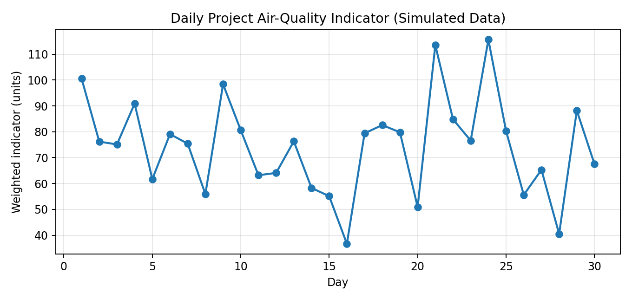
Figure 1. Daily weighted project indicator for simulated values. This is not the official AQI.
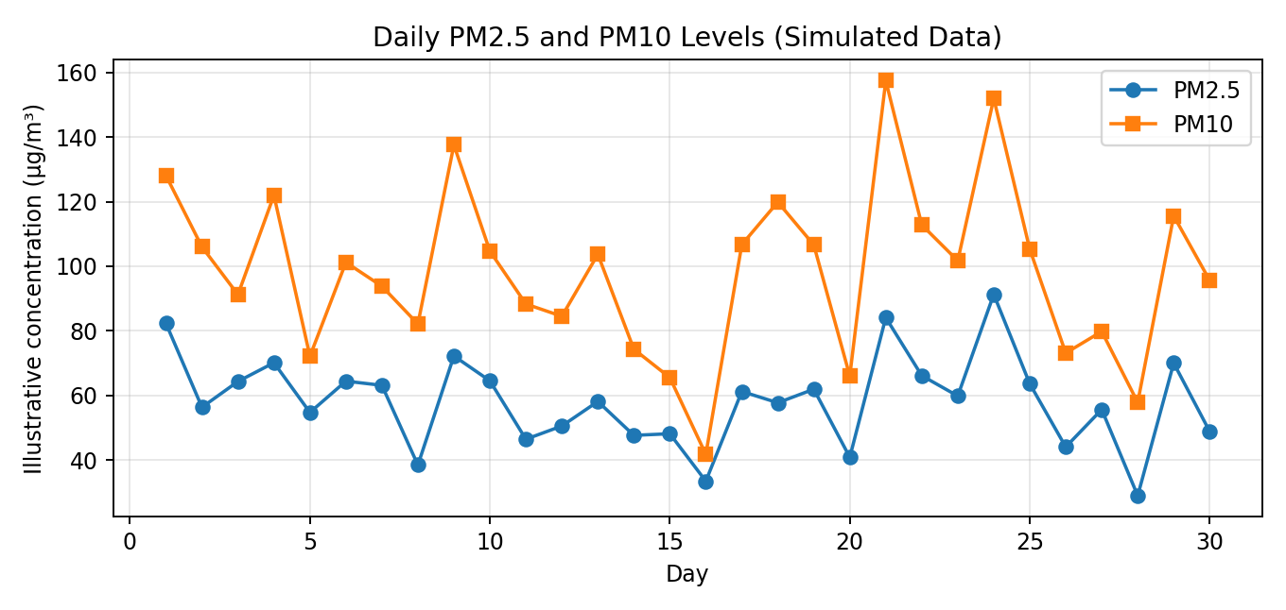
Figure 2. PM2.5 and PM10 comparison across 30 simulated days.
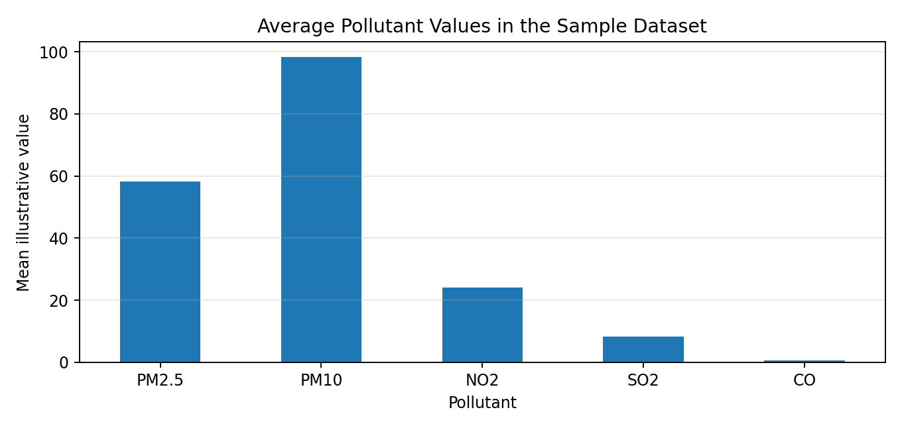
Figure 3. Average values for pollutant columns in the sample dataset; units should be checked before cross-pollutant comparison.
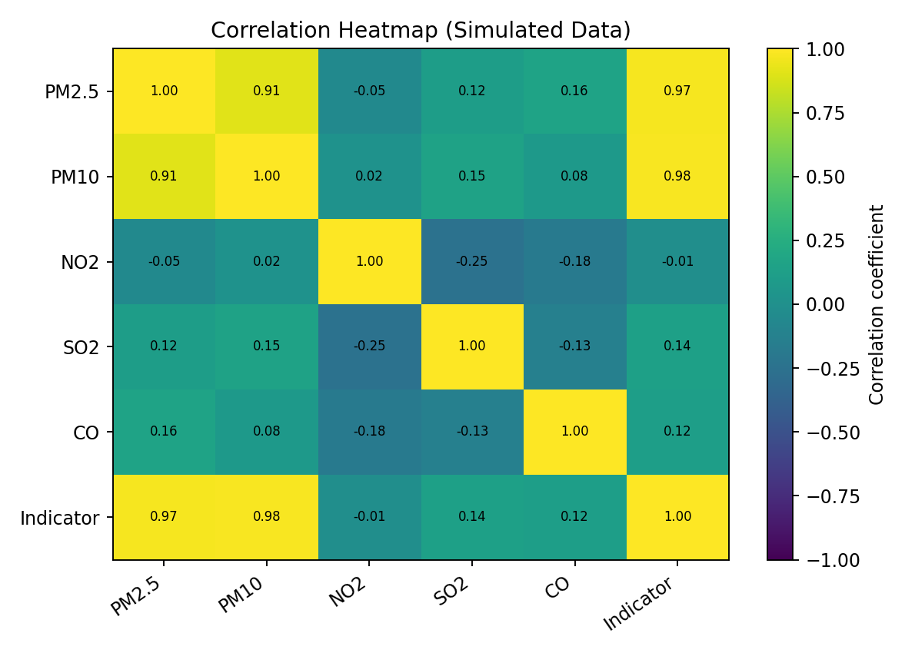
Figure 4. Correlation heatmap. Correlation indicates association, not cause and effect.

11. Conclusion
This case study meets its learning purpose by demonstrating how Python libraries can be combined for basic air-quality data analysis. The workflow generates structured data, calculates a derived project indicator, summarizes pollutant columns, and presents trends and relationships through graphs. Clear labelling and discussion of limitations are essential parts of responsible data science.
The most important limitation is that the dataset is simulated. Therefore, the graphs are examples of the analysis process, not evidence of measured air quality in Chandigarh. A future extension should use validated data from recognized monitoring stations, include exact dates and units, document missing-data handling, and compare any AQI calculation with the official methodology before making public or health-related claims.

12. Learning Outcomes
• Learned to structure numerical observations in a pandas DataFrame and export them to CSV.
• Practised generating and handling numerical values with NumPy.
• Used line charts to inspect changes across days and a bar chart to compare averages.
• Used a correlation matrix to explore relationships among variables.
• Learned to state assumptions, label figures and avoid treating simulated data as real observations.
• Recognized that a custom weighted metric must not be called official AQI without the correct methodology.

- 13. References
1. Central Pollution Control Board (CPCB), Government of India — official air-quality information and AQI resources: https://cpcb.nic.in/ (consult the current official material before using real measurements or AQI calculations).
2. pandas documentation — https://pandas.pydata.org/docs/ — DataFrame operations and CSV input/output.
3. NumPy documentation — https://numpy.org/doc/ — numerical arrays and statistical operations.
4. Matplotlib documentation — https://matplotlib.org/stable/ — plotting and figure export.
5. Project dataset: simulated educational data generated for this report; it is not an external observation source.

14. Screenshots and Project Evidence
Project evidence included in this report: four generated figures showing the daily project indicator, PM2.5/PM10 comparison, average pollutant values and a correlation heatmap. These figures can be used in a project blog or GitHub README with a caption explaining that the data are simulated. Do not label these charts as official measurements.
Recommended GitHub contents: the Python script, the CSV dataset, the four PNG figures, this report, a README describing setup and execution, and a note explaining the simulation and non-official indicator. Add your own repository and blog links after publishing; they have not been created by this report.

[screenshot for upload in any blog (linkedin/medium)]

[screenshots for upload in github]

Appendix A — Python Code
# Air Quality Data Analysis of Chandigarh
# EDUCATIONAL DEMONSTRATION: values are simulated, not real observations.
# The weighted indicator below is NOT the official CPCB AQI.
import numpy as np
import pandas as pd
import matplotlib.pyplot as plt
np.random.seed(7)
days = np.arange(1, 31)
pm25 = np.clip(np.random.normal(58, 13, 30) + 7*np.sin(days/3), 20, 105).round(1)
pm10 = np.clip(pm25 * 1.55 + np.random.normal(8, 10, 30), 35, 190).round(1)
no2 = np.clip(np.random.normal(24, 6, 30), 8, 42).round(1)
so2 = np.clip(np.random.normal(8, 2, 30), 2, 15).round(1)
co = np.clip(np.random.normal(0.8, 0.2, 30), 0.2, 1.5).round(2)
data = pd.DataFrame({
"Day": days,
"PM2.5": pm25,
"PM10": pm10,
"NO2": no2,
"SO2": so2,
"CO": co
})
data["Project Indicator (not official AQI)"] = (
0.6 * data["PM2.5"] + 0.4 * data["PM10"]
).round(1)
print("First five rows:")
print(data.head())
print("\nSummary statistics:")
print(data.describe().round(2))
print("\nMean pollutant values:")
print(data[["PM2.5", "PM10", "NO2", "SO2", "CO"]].mean().round(2))
# Save the generated dataset
data.to_csv("simulated_chandigarh_air_quality.csv", index=False)
# Figure 1: Daily derived project indicator
plt.figure(figsize=(9, 4))
plt.plot(data["Day"], data["Project Indicator (not official AQI)"], marker="o")
plt.title("Daily Project Indicator (Simulated Data)")
plt.xlabel("Day")
plt.ylabel("Weighted indicator (not official AQI)")
plt.grid(True, alpha=0.3)
plt.tight_layout()
plt.savefig("daily_indicator.png", dpi=160)
plt.show()
# Figure 2: PM2.5 and PM10 comparison
plt.figure(figsize=(9, 4))
plt.plot(data["Day"], data["PM2.5"], marker="o", label="PM2.5")
plt.plot(data["Day"], data["PM10"], marker="s", label="PM10")
plt.title("PM2.5 and PM10 (Simulated Data)")
plt.xlabel("Day")
plt.ylabel("Illustrative concentration (µg/m³)")
plt.legend()
plt.grid(True, alpha=0.3)
plt.tight_layout()
plt.savefig("pm_levels.png", dpi=160)
plt.show()
# Figure 3: Mean pollutant values
means = data[["PM2.5", "PM10", "NO2", "SO2", "CO"]].mean()
means.plot(kind="bar", figsize=(9, 4), title="Mean Pollutant Values (Simulated Data)")
plt.xlabel("Pollutant")
plt.ylabel("Mean illustrative value")
plt.tight_layout()
plt.savefig("average_pollutants.png", dpi=160)
plt.show()
# Figure 4: Correlation heatmap using Matplotlib
cols = ["PM2.5", "PM10", "NO2", "SO2", "CO",
"Project Indicator (not official AQI)"]
corr = data[cols].corr()
plt.figure(figsize=(8, 5))
plt.imshow(corr, vmin=-1, vmax=1, aspect="auto")
plt.colorbar(label="Correlation coefficient")
labels = ["PM2.5", "PM10", "NO2", "SO2", "CO", "Indicator"]
plt.xticks(range(len(labels)), labels, rotation=35, ha="right")
plt.yticks(range(len(labels)), labels)
plt.title("Correlation Heatmap (Simulated Data)")
for row in range(len(labels)):
for col in range(len(labels)):
plt.text(col, row, f"{corr.iloc[row, col]:.2f}",
ha="center", va="center", fontsize=8)
plt.tight_layout()
plt.savefig("correlation_heatmap.png", dpi=160)
plt.show()
print("\nNote: These data are simulated and the weighted indicator is not official AQI.")

15. Evaluation Grid (to be completed by faculty)
Sr. No. | Parameters | Marks Obtained | Maximum Marks
1. | PROJECT TITLE |  | 2 Marks
2. | CASE STUDY |  | 5 Marks
3. | Github Upload Link |  | 1 Marks
4. | Blog Upload Link |  | 1 Marks
5. | Follow Format |  | 1 Marks
 | TOTAL |  | 10 Marks
 | AVG |  | 6 Marks

Teacher Signature

